Fairbanks Coordinated Entry System Protocols
2018

Fairbanks Housing & Homeless Coalition
4/9/2018

Table of Contents
Overview 2
Coordinated Entry System 2
Geographical Area 2
Agency Participation 3
Designated Lead Agency/Organization 3
Access Points 4
Assessments 4
Prioritization 5
Referrals 5
Case Conferencing 5
Grievance Policy 6
Evaluation and Training 6
Acronym List 7

Figure 1: Fairbanks North Star Borough Interior Alaska 2

Overview
This document serves as the Fairbanks Referral Zone supplement to the Alaska Coalition on Housing and Homelessness (AKCH2) Coordinated Entry Policies and Procedures and is also intended to comply with the Alaska Balance of State (BoS) Continuum of Care (CoC) Policies and the Alaska Homeless Management Information System (HMIS) Policies and Procedures.

AKCH2 Coordinated Entry Policies and Procedures
https://static1.squarespace.com/static/58d2e051725e25221a22bfe7/t/5ac7e534758d46d0df8c4f7a/1523049784053/Alaska+Balance+of+State+Coordinated+Entry+Policies+%26+Procedures.pdf

BoS CoC Policies
https://static1.squarespace.com/static/58d2e051725e25221a22bfe7/t/5a45b7c20852292beed210d6/1514518471809/BoS+CoC+Policies+and+Procedures.pdf

Alaska HMIS Policies and Procedures
https://www.icalliances.org/s/AKHMIS-Policies-and-Procedures-2016-dez6.pdf

Coordinated Entry System
The Coordinated Entry System (CES) is a process developed to connect people experiencing homelessness/near homelessness with the appropriate community resources to overcome their housing barriers. The United States Department of Housing & Urban Development (HUD) recognized that most communities lack sufficient service capacity to meet their needs and created CES ensure communities could triage interventions. The Fairbanks’ CES is designed to prioritize housing solutions based upon clients’ needs as determined by the Alaska BoS common assessment. All CES agencies will use a phased assessment, which includes the Vulnerability Index - Service Prioritization Decision Assistance Tool (VI-SPDAT) 2.0 as their common assessment tool. This tool helps determine prioritization for services, but does not change eligibility requirements for program admission.

Geographical Area

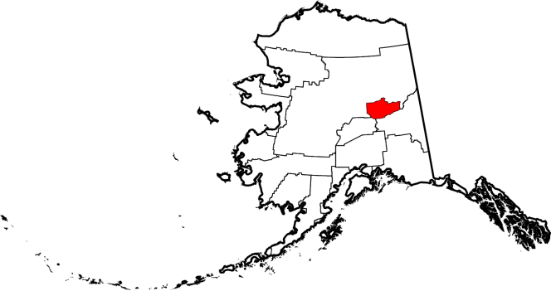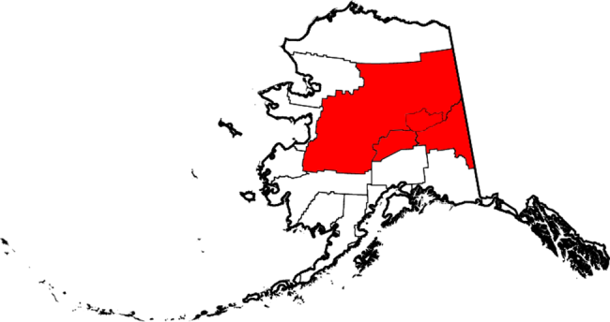

Figure 1: Fairbanks North Star Borough Interior Alaska
The Fairbanks Referral Zone is a mountainous region situated north and south of the Arctic Circle. The zone is vast, covering an area larger than the state of Texas, but has an estimated population of fewer than 115,000 people. Approximately 100,000 of the 115,000 people live in the Fairbanks North Star Borough (FNSB), an area roughly the size of New Jersey. Within the FNSB, most of the population lives in Fairbanks and the surrounding communities of North Pole, Fort Wainwright, Eielson Air Force Base, Fox, Nenana, and Salcha. There is well maintained network of roads between the communities of FNSB and travel is common even in the snowy winter months. The Denali Borough communities to the South of FNSB, such as Healy and Clear also have easy access to Fairbanks, although sometimes winter conditions make this trip more difficult. Travel by road to and from Delta Junction and Fort Greely in the Southeast Fairbanks Census Area is also feasible anytime of the year, but can be more hazardous in winter months. Travel to the more remote villages of Interior Alaska varies greatly from village to village and by time of the year. The most remote of villages can only be reached through a combination of travel methods including bush planes, boats and All-Terrain Vehicles in summer months and snow machines during the fall, winter, and spring months.

Fairbanks is the resource hub for Interior Alaska. All the CES service agencies for Interior Alaska are located in the Fairbanks area. Most of the clients that access CES services normally reside in Fairbanks, but occasionally a village resident temporarily seek CES services. Usually this just consists of a short stay in the Fairbanks Rescue Mission if other living arrangements were unavailable while conducting business in Fairbanks. Some local organizations routinely help with travel to and from the more remote communities and often provide temporary housing while the person is in Fairbanks, but it is unlikely these services would be used to receive CES services. The Fairbanks CES will welcome any referral within Interior Alaska, but realistically the client will need to be in the Fairbanks area to truly access CES services.

Agency Participation
Any agency that receives Continuum of Care (CoC), Emergency Services Grants (ESG), Supportive Services for Veteran Families (SSVF), or Basic Homeless Assistance Program (BHAP) funding are required by their funders to participate in the Coordinated Entry System. The Coordinated Entry System is designed to expand to include as many organizations as possible, regardless of funding source, in an effort to reduce barriers to essential services. A current CES participation list is available upon request by emailing fairbankshomeless@gmail.com.

Designated Lead Agency/Organization
Until otherwise noted the Fairbanks Housing & Homeless Coalition (FHHC) will serve as the Designated Lead Agency/Organization (DLA/O) for the Fairbanks Referral Zone. The BoS Coordinated Entry Policies and Procedures require the DLA/O to perform the following duties:
- Manage the prioritization list
- Ensure fidelity of local access points
- Coordinate marketing efforts
- Monitor system performance
- Serve as a liaison between the CoC and Referral Zone

Access Points
The initial access points for the Fairbanks Referral Zone are illustrated in the figure below. Each agency has agreed to be an access point to CES for the population demographics their respective programs service. This model is a variation of the “no wrong door” approach in that agencies serving unaccompanied youth or people currently fleeing domestic violence (DV) would not be an access point for all other populations. Additionally, as Alaska’s 211 system is developed to enhance CES, phone and online intakes may become available. The current list of Access Points is available at https://www.fairbankshomeless.org/coordinated-entry-system.html.

Assessments
The Fairbanks CES will follow the AKCH2 Coordinated Entry Policies and Procedures for assessment and use the same assessment standards as adopted by the entirety of the BoS. Additionally Fairbanks agencies have set a goal of having the entire assessment packet including the VI-SPDAT completed within three weeks of a client entering a program. While any CES participating agency can work on an assessment the responsibility to complete the assessment falls on the program in which the client is enrolled rather than the referring agency. For example if the Salvation Army refers a client to the Fairbanks Rescue Mission for Rapid Re-Housing and the Fairbanks Rescue Mission accepts the referral, then the Fairbanks Rescue Mission would be responsible for ensuring the assessment is completed to standard.

Prioritization
The Fairbanks CES will follow the AKCH2 Coordinated Entry Policies and Procedures for prioritization. The local “tie breaker” criterion will be the length of time on the prioritization list. Additionally, the Fairbanks CES would like to stress that prioritization does not change program eligibility requirements. For example if a PSH bed specifically funded for DV were to open, a non-DV client could not take that bed.

Referrals
The Fairbanks CES will follow the AKCH2 Coordinated Entry Policies and Procedures for referrals.

Case Conferencing
Formal case conferencing in Fairbanks will be at least monthly as mandated by the AKCH2 Coordinated Entry Policies and Procedures, but should be reserved for clients struggling with barriers. With most clients there is no reason to wait for the formal case conferencing. Case Conferencing should be for the clients that otherwise would “fall through the cracks”. Case managers, social workers, counselors, clinicians, etc. are strongly encouraged to reach out to service providers from other agencies as needed to best assist their respective clients.

Duties:
- The DLA/O will establish and host the first case conference, but each following month a different agency will host on a rotational basis.

- The DLA/O will assist in communicating the meetings to the proper agencies.

- The DLA/O will present the prioritization lists at each case conference.

- Agencies will present any case they are struggling with.

- Agencies will address any referral they rejected and reasons why

- Agencies will need to have applicable data entered into HMIS about the client(s) they are representing prior to the case conference.

- If an agency does not have any clients to represent for the case conference, the agency still needs to have representation at the case conference to assist other agencies.

- The DLA/O will work to incorporate essential service providers (not already participating in CES) into the data sharing agreement so that these services can participate in case conferencing.

Grievance Policy
The Fairbanks CES will follow the AKCH2 Coordinated Entry Policies and Procedures for grievances. Additionally grievances may be directed to the DLA/O rather than directly to AKCH2 CoC Executive Director Committee.

Evaluation and Training
The Fairbanks CES will follow the AKCH2 Coordinated Entry Policies and Procedures for evaluations and training.

Acronym List

AKCH2 Alaska Coalition on Housing and Homelessness

BHAP Basic Homeless Assistance Program

BoS Balance of State

CES Coordinated Entry System

CoC Continuum of Care

DLA/O Designated Lead Agency/Organization

DV Domestic Violence

ESG Emergency Services Grants

FHHC Fairbanks Housing & Homeless Coalition

FNSB Fairbanks North Star Borough

FYA Fairbanks Youth Advocates

HUD United States Department of Housing & Urban Development

IACNVL Interior Alaska Center for Non-Violent Living

PSH Permanent Supportive Housing

RRH Rapid Re-Housing

VI-SPDAT Vulnerability Index - Service Prioritization Decision Assistance Tool

