Fairbanks Housing & Homeless coalition Strategic Plan

FHHC Strategic Plan for 2019-2020 based upon a review of the 2013 FHHC Ten Year Plan with input from the FHHC Strategic Planning Committee & FHHC Board
  - 2019-2020

Contents
Executive Summary 2
2019 Ten Year Plan Prioritization 3
TYP: Housing Services 4
Prevention / Diversion Project 4
Transitional Housing 4
Permanent Supportive Housing 4
Increased Low Income Housing 4
Master Lease Program 4
Rapid Re-Housing 5
TYP: Supportive Services 5
Bridges Out of Poverty 5
Street / Camp Outreach 5
Assertive Community Treatment / Intensive Case Management 6
Project Homeless Connect 6
Day Shelter 6
Coordinated Entry System 6
FHHC Operations 7
FHHC Sustainability 7
Board Meetings 8
Involvement with Other Coalitions 8
FHHC Outreach 8

Figure 1: 2018 Ten Year Plan Prioritization 3

Executive Summary
With just under four years left on the July 1, 2013 Ten Year Plan (TYP), the Fairbanks Housing & Homeless Coalition (FHHC) is prepared to accomplish its TYP objectives. All last year’s top priorities were accomplished. The pinnacle of these accomplishments was the creation and implementation of the Coordinated Entry System (CES) and a Rapid Re-Housing (RRH) program. Both projects were collaborative projects involving around a dozen agencies.

The FHHC Strategic Planning Committee with oversite from FHHC Board Members reviewed the 2018 TYP prioritization in June and July 2019. The group first agreed to add a maintenance section to the prioritization and placed five established, ongoing objectives in the new section. The group then changed the priority of eight objectives, added three new objectives, and removed one objective. (Please see Figure 1 for current prioritizations)

The top priorities for the FHHC include:
- creating a multi-agency prevention/diversion project
- conducting Bridges Out of Poverty and Getting Ahead courses
- greatly increasing street/encampment outreach to connect people to services
- strengthening FHHC sustainability
- conducting quarterly board meetings to monitor progress.

Other notable priorities include:
- exploring Transitional Housing options for specified populations
- advocating for low-income housing, especially for seniors
- continuing to investigate options for Intensive Case Management and/or Assertive Community Treatment teams

The only removed objective was an additional emergency shelter objective. The Strategic Planning Committee discussed the objective and determined that between the Fairbanks Rescue Mission, Interior Alaska Center for Non-Violent Living (IACNVL), Fairbanks Youth Advocates (FYA), and Tanana Chiefs Conference (TCC) Sobering Center most if not all populations have an acceptable emergency shelter with adequate capacity.

The only significantly altered objective changed Project Homeless Connect (PHC) from twice per year to once per year, with the intent of pushing the resources from the summer PHC to street/encampment outreach.

2019 Ten Year Plan Prioritization

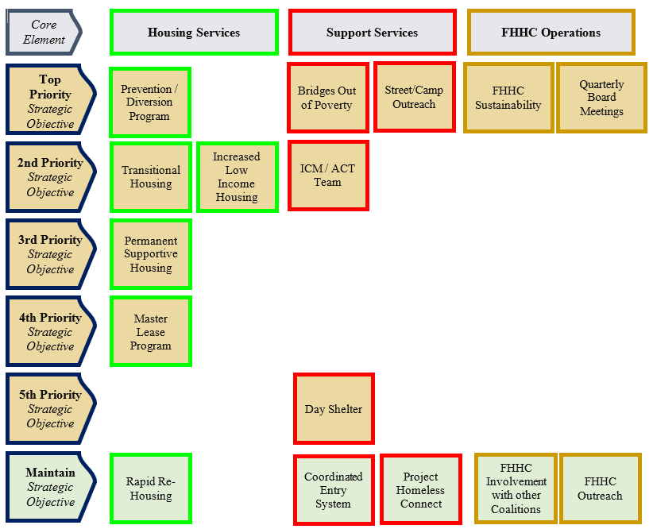
Top Priority: Actively pursuing / project in the execution stage
2nd Priority: Actively pursuing / project in planning stage
3rd Priority: Actively pursuing / project in the initiation stage
4th Priority: Considering / research needed
5th Priority: On hold / research completed / not actively pursuing, but open to project opportunities
Maintain: Project established and on going

Figure 1: 2019 Ten Year Plan Prioritization

TYP: Housing Services

Prevention / Diversion Project
Recent changes to the Alaska state budget have eliminated an important prevention diversion program in Fairbanks. Fortunately, well before the budget cuts were announced the FHHC was exploring prevention and diversion (P&D) best practices. Members of the FHHC Board and FHHC Coordinator were already planning to add a multi-agency P&D project to the prioritization list, but with recent fiscal changes have decided to make it a top priority. Funding P&D projects are always the most difficult to fund and manage, but they are also the most effective and cost efficient. The Strategic Planning Committee believes a P&D project can be established, funded, and staffed this year, despite changes to the Alaskan economy.

Transitional Housing
The Strategic Planning Committee closely examined Transitional Housing (TH) models this year. The committee found that there is still need for an expansion of TH programs in Fairbanks for specific populations that tend to be unsuccessful in or ineligible for RRH. For safety and practical reasons, people fleeing Domestic Violence (DV) tend to need more than a year to overcome their housing barriers. The FHHC will continue to look for ways to support local DV TH programs.
There is evidence that young adults (18-25) who experience homelessness tend to fair better in TH than RRH. There are two local agencies exploring TH programs for this people experiencing homelessness in this age demographic. The FHHC will support these efforts if possible. Additionally, the FHHC is already supporting the Alaska Coalition on Housing & Homelessness (AKCH2) efforts to apply for the Youth Homeless Demonstration Program, which would likely result in TH programs across the state for young adults experiencing homelessness.

Permanent Supportive Housing
The FHHC remains committed to looking for more Permanent Supportive Housing (PSH) opportunities. While there are currently not any FHHC led PSH projects, there are a few organizations actively exploring additional PSH units. The FHHC will support these programs as feasible.

Increased Low Income Housing
The Strategic Planning Committee recognizes that despite a relatively high vacancy rate in Fairbanks there does seem to be a lack of low cost rentals. This is especially true with senior housing. It is estimated that Fairbanks needs 148 more affordable senior housing units. The FHHC has reached out to several low income housing organizations with varying degrees of success. Currently it appears The Salvation Army is willing to commit to 36 new units, which is a great start, but the FHHC will need to continue efforts for additional low income housing options.

Master Lease Program
The FHHC Strategic Planning Committee observed that the FHHC needs to learn more about such programs. Master Lease programs are very limited in Alaska. My House in Wasilla, AK does have a successful Master Lease program.

Rapid Re-Housing
Beginning in December 2017 the FHHC planned and developed a multiagency shared Rapid Re-Housing (RRH) program that promotes consumer choice in the private rental market for clients of the Coordinated Entry System (CES) through landlord engagement, case management, and tapering financial support. This program follows the National Alliance to End Homelessness (NAEH) / Supportive Services for Veteran Families (SSVF) standards and benchmarks for RRH. This was a truly collaborative endeavor between the following organizations:

- Alaska Mental Health Trust Authority
- City of Fairbanks
- Fairbanks Housing & Homeless Coalition (FHHC)
- Fairbanks Native Association (FNA)
- Fairbanks Rescue Mission
- Fairbanks Youth Advocates (FYA)
- Interior AIDS Association (IAA)
- Interior Alaska Center for Non-Violent Living (IACNVL)
- Love INC
- No Limits Inc.
- The Salvation Army

The Fairbanks Rescue Mission was unanimously chosen to host the program and has successfully ran the program since its launch in 2018.

TYP: Supportive Services

Bridges Out of Poverty
In 2017, the FHHC explored the possibility of hosting Bridges Out of Poverty training, but ultimately decided it was too expensive. Since then the FHHC in partnership with Interior AIDS Association and the Fairbanks Reentry Coalition has hosted a Bridges Out of Poverty book club, a training webinar, and has gotten instructors certified to teach the program. Currently, Love In the Name of Christ has two instructors, the Fairbanks Reentry Coalition has an instructor, and IACNVL has an instructor who can also teach the Getting Ahead in a Just Getting By World course. The FHHC recently purchased the materials needed to start teaching both courses and plans to raise funds to offer the courses to the public at no cost. The Fairbanks Reentry Coalition has tasked their AmeriCorps VISTA Member with transforming the courses into a sustainable program. Due to the amount of recent community support for the program, recent trainings, and ability to launch Bridges and Getting Ahead, this objective has been moved to a top priority.

Street / Camp Outreach
People that experience episodes of unsheltered homelessness have a life expectancy that is 26 years less than somebody that is housed, and they are twice as likely to be victims of a serious violent crime. There is a population of roughly 50 people in the community that are living in encampments and refuse services. Currently, the Fairbanks Rescue Mission and Angels In Motion coordinate the bulk of street / encampment outreach efforts. Both organizations are very involved with the FHHC and are looking to greatly increase outreach efforts to people living on the streets or in encampments. Fortunately, in Fairbanks nearly anybody experiencing homelessness can be housed quickly and permanently, but only if they are willing to participate in services. The goal of increasing outreach is to build rapport with these individuals to persuade them to seek the services needed to overcome their housing barriers. This is the missing aspect in the local housing/homelessness service network. This objective will include:
- Strengthening current outreach efforts
- Offering services in different locations (Stone Soup Café, libraries)
- Mobile Coordinated Entry System enrollment
- Discouraging panhandling
- Educating the public on available resources

Assertive Community Treatment / Intensive Case Management
Last year, the Strategic Planning Committee combined and updated the TYP objectives “After Hours Case Management” and “Advocate for Behavioral Health Options” to “Assertive Community Treatment / Intensive Case Management”. In 2015, the Alaska Department of Health and Social Services (DHSS) officially outlined the Assertive Community Treatment (ACT) and Intensive Case Management (ICM) program standards. Either program would meet the intent of the previous TYP objectives and developing such a program in Fairbanks appears to be achievable. Currently Anchorage has an ACT and ICM team and Juneau is in the process of building an ACT team.
Several local agencies have expressed interest in developing an ACT and/or ICM team in Fairbanks. he FHHC hosted a discussion about ACT/ICM and approximately 40 local stakeholders participated. Then the FHHC hosted a symposium with over 200 people in attendance to explore the possibility of ACT/ICM. Surveys from the symposium suggest that the community feels Fairbanks is much more prepared to establish an ICM Team than an ACT. ICM is much less expensive and the case managers would be easier to recruit than the ACT team members.

Project Homeless Connect
The FHHC will continue to participate in the statewide Project Homeless Connect (PHC) events every January, but to focus resources on street/encampment outreach will not host additional PHC events. Most PHC participants are already connected to services and most people living in encampments do not attend PHC.

Day Shelter
In 2017, the FHHC extensively examined day shelter possibilities, but after several setbacks determined the project should be shelved until a suitable agency has the capacity to take the lead on such an endeavor.

Coordinated Entry System
The Alaska Balance of State (BoS) Continuum of Care (CoC) has implemented the federally mandated Coordinated Entry System (CES). The Strategic Planning Committee updated the TYP objective “Increase HMIS Participation” to “Coordinated Entry System”, because CES naturally encompasses increasing the Homeless Management Information System (HMIS).
The Fairbanks Referral Zone is the entirety of Interior Alaska. This is the largest referral zone in the country, but it is sparsely populated with nearly the entire population living in the Fairbanks Metropolitan Area.
Fairbanks was the first community in the CoC to have approved CES policies and procedures. The FHHC was selected by the CoC to be the Designated Lead Agency/Organization (DLA/O). This has added some additional work to the coalition, but should make it easier for local agencies to participate in CES. Some of the additional duties include:
- Manage the prioritization list
- Ensure fidelity of local access points
- Coordinate marketing efforts
- Monitor system performance
- Serve as a liaison between the CoC and Referral Zone

FHHC Operations

FHHC Sustainability
The FHHC is currently looking for long-term organizational sustainability. First it seems that the Alaska Mental Health Trust Authority is willing to fund the coordinator position for another three years. The position is currently funded until 2021. During a March 2018 Trust meeting, the Trustees appeared genuinely pleased with the position. The Trust currently funds three municipal Housing & Homeless Coordinator positions. All three coordinators have organized significant housing projects. Fairbanks is the only community that has expressly stated that the position will also serve as the local coalition’s coordinator. In all other communities these positions are separated. This ensures the FHHC will have at least one full time employee until 2021. To extend beyond 2021 the FHHC will need to either find alternative funding sources or continue to demonstrate the effectiveness of the position.
The FHHC is under the fiscal supervision of the North Star Community Foundation (NSCF), because the FHHC is not a stand-alone 501c3 organization. This arrangement allows the FHHC to apply for grants that require 501c3 status, but often limits what funding sources may be used as it puts the FHHC in competition with other NSCF organizations. The NSCF is essentially operated by one person, who has an impressive travel schedule making the NSCF somewhat unreliable. This arrangement failed repeatedly in 2017 resulting in lost funding opportunities. While conditions have greatly improved over the past six months, the current arrangement should not be considered a long-term solution. The FHHC needs to be ready to become an independent 501c3 at any time. With the establishment of by-laws in 2017, and the election of a board in 2018 the FHHC is poised to meet the standards of the Alaska Nonprofit Corporation Act, should the need arise.
The FHHC currently operates in a project to project funding cycle that leaves little if any funding for operational expenses. Fortunately, outside project expenses, the FHHC operates with few overhead costs. In the past the coordinator has paid for some outside expenses out of pocket due to a lack of funds, but recently local donations have kept the FHHC assets around $10,000.

Board Meetings
The FHHC Board has decided to start having quarterly board meetings. Because the FHHC is not incorporated this has not been a requirement in the past.

Involvement with Other Coalitions
The FHHC remains committed to collaboration with other coalition style organizations including: Alaska Coalition on Housing & Homelessness (AKCH2), North Star Community Foundation (NSCF), Fairbanks North Star Borough Air Quality Stakeholders Group, Fairbanks Opioid Workgroup, Arctic Alliance for People, Re-entry Coalition, Mobility Coalition, and Wellness Coalition. The FHHC is in constant communication and cooperation with AKCH2. The NSCF is the FHHC’s fiscal agent and the FHHC assists NSCF and its member agencies as appropriate. The FHHC is very much aligned with Re-entry Coalition with both organizations in constant communication and continually supporting mutually beneficial projects. The FHHC has varying levels of engagement with the other listed organizations and will support their activities as appropriate.

FHHC Outreach
The FHHC has been granted an AmeriCorps VISTA to serve as a full-time Outreach Coordinator until August 2019. The Outreach Coordinator leads the Outreach Committee and coordinates FHHC outreach. The three primary outreach focuses are to people experiencing homelessness, to agencies providing services for people experiencing homelessness, and to the community in general. After August 2019 the Outreach Coordinator position will be filled by a volunteer from the FHHC.

